Case Study Draft

**Case Study Title- Impact Focus**

* COLT-X: The Use of AI for Network Automation and Network Optimization

**PROJECT SCOPE- NABC Format (Innovation Navigator)**

* What company are you working with and what do they do that presents a problem which defines your project scope?
  + We had the opportunity to work with Colt Technology Services, a multinational telecommunications company headquartered in the UK. It transforms the way the world works through the power of connectivity and provides a world-class network and voice connectivity to businesses in Europe, Asia and the US. Since network connectivity is in such high demand, adopting the use of AI to optimize the network is extremely valuable for both Colt and society as a whole.
* Why the collaboration between Colt and Berkeley? What value does Berkeley Innovation-X have?
  + Colt provides network services in X locations. These networks require bandwidth. Talk about why we need network traffic management in order to optimally assign relevant bandwidth.
  + This was Colt’s first experience collaborating with a university to bridge their industry with academics and challenge students to use their technical and problem solving skills to meet their goals. The Innovation Engineering framework combines technology, entrepreneurial behavior, and design to achieve successful, rapid, innovation. It’s based on 15 years of learning at UC Berkeley. In the case of Colt, it allows the Berkeley students and departments to help the company expand into different industries, such as AI and machine learning, to improve the efficiency of its products.

**Challenge**

* Connect to project scope
* Network traffic management for automation and optimization (refer to traffic shaping tutorial recording)

**Innovation-X Solution**

* 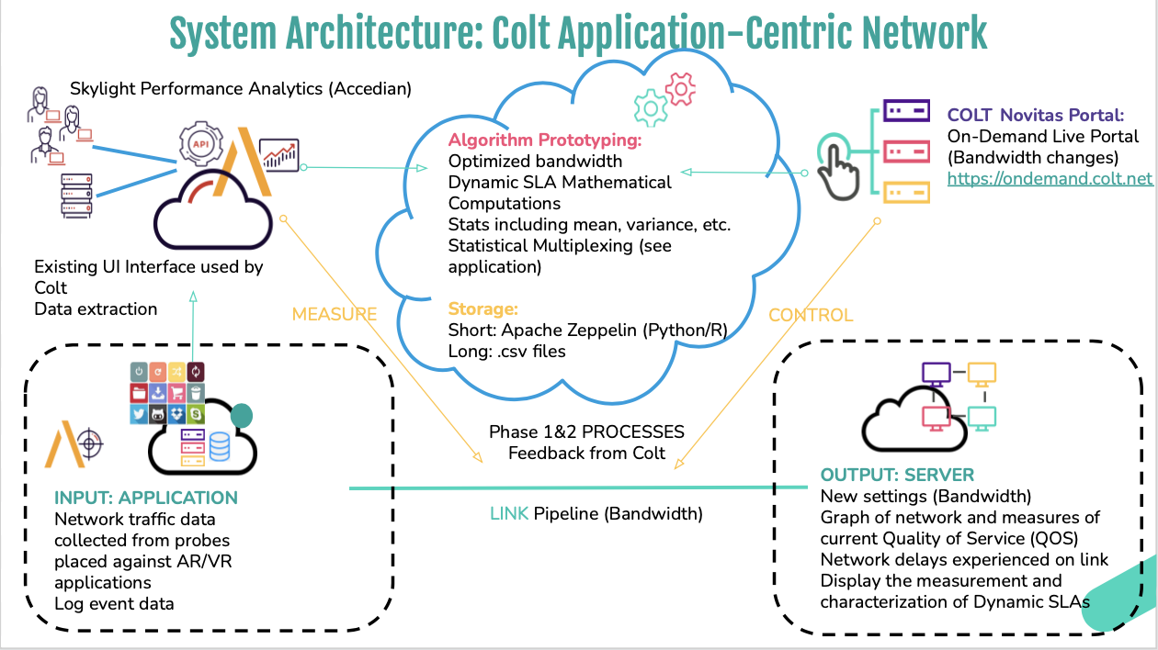
* Technology Strategy- write

**Results**

* Provide screenshot of Anvil final web design
  + Explain features briefly

**What do you want people who read the case study to take away from your project experience?**

* For student innovators, by student innovators- what you want future x-labs students to expect
* For advisors and company team- what you want future partners to know

**Future Work**

* How are you preparing this project to translate into a university course for another team to continue?
* If your project is ending, what are the next steps on the company’s end to implement your tool or use your project to inform their decisions?

**Innovation-X Seminar- students, faculty and mentors, including corporate sponsors and SCET Executive Scholars**

* Embed Innovation-Seminar sessions (recorded)

**Quotes- validation information (Innovation Navigator)**

* From each person on the industry team about their experience collaborating with an educational institution
  + Valéry Augais, Network Architect
  + Francesca Serravalle, Emerging Technology Director

**Who is COLT-X?**

* Highlight the opportunity to work with industry experts and directly receive mentorship and project guidance

**Meet the team**

* Innovation-X student team
  + Isabel Zavian
  + Noor Ul-Ain Ali
  + Ronel Solomon
  + Peter Li
  + Charline Shen
  + Andy Lam
* Project Manager
  + Elisa Balestra, GSMA (AI)

**Advisors**

* Ikhlaq Sidhu
* Debashis Chatterjee, Senior Director of Software Engineering at Intel Corporation
* Accedian team
  + Valéry Augais
  + Francesca Serravalle
* Jennifer Nice

